Recycler App

Ana Gleisy Moreira dos Santos RA:1211084 - Guilherme Augusto dos Santos Diogo RA: 12110078 - Igor Muniz de Melo RA: 12109922 - Pedro Felipe Gobb Teixeira RA 12109892 – William Jaques Ferreira Dias RA: 12109688

**https://morinato.atlassian.net/jira/software/projects/RA/boards/2/roadmap?shared=&atlOrigin=eyJpIjoiMGMxNWQ3MjEyNmE4NDMyNjlkNGFlZTFhMzA0MWNmYmEiLCJwIjoiaiJ9**

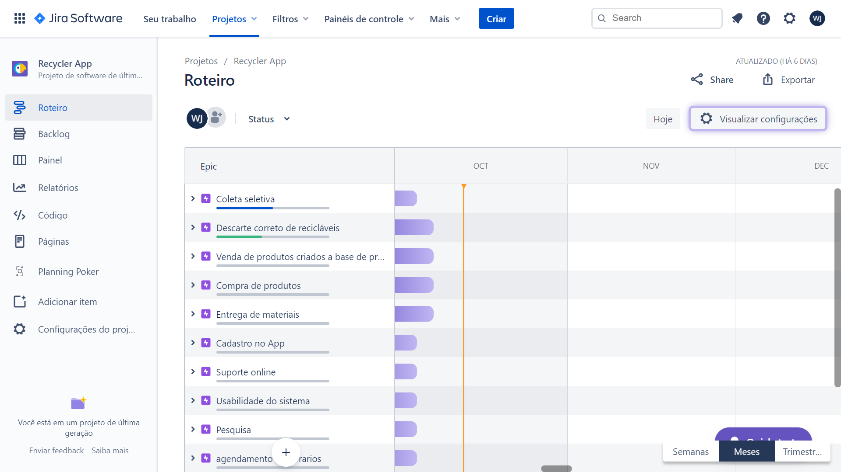

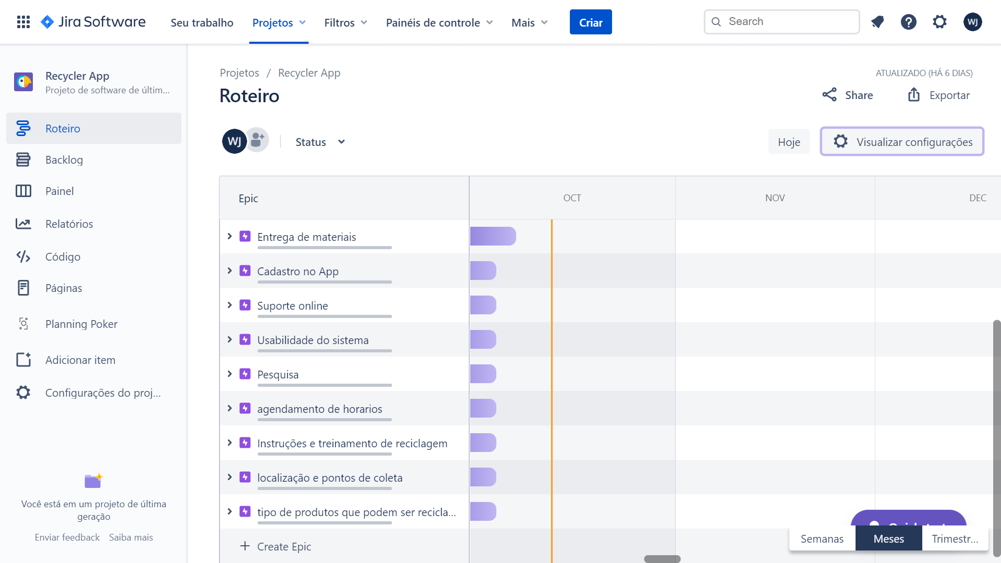

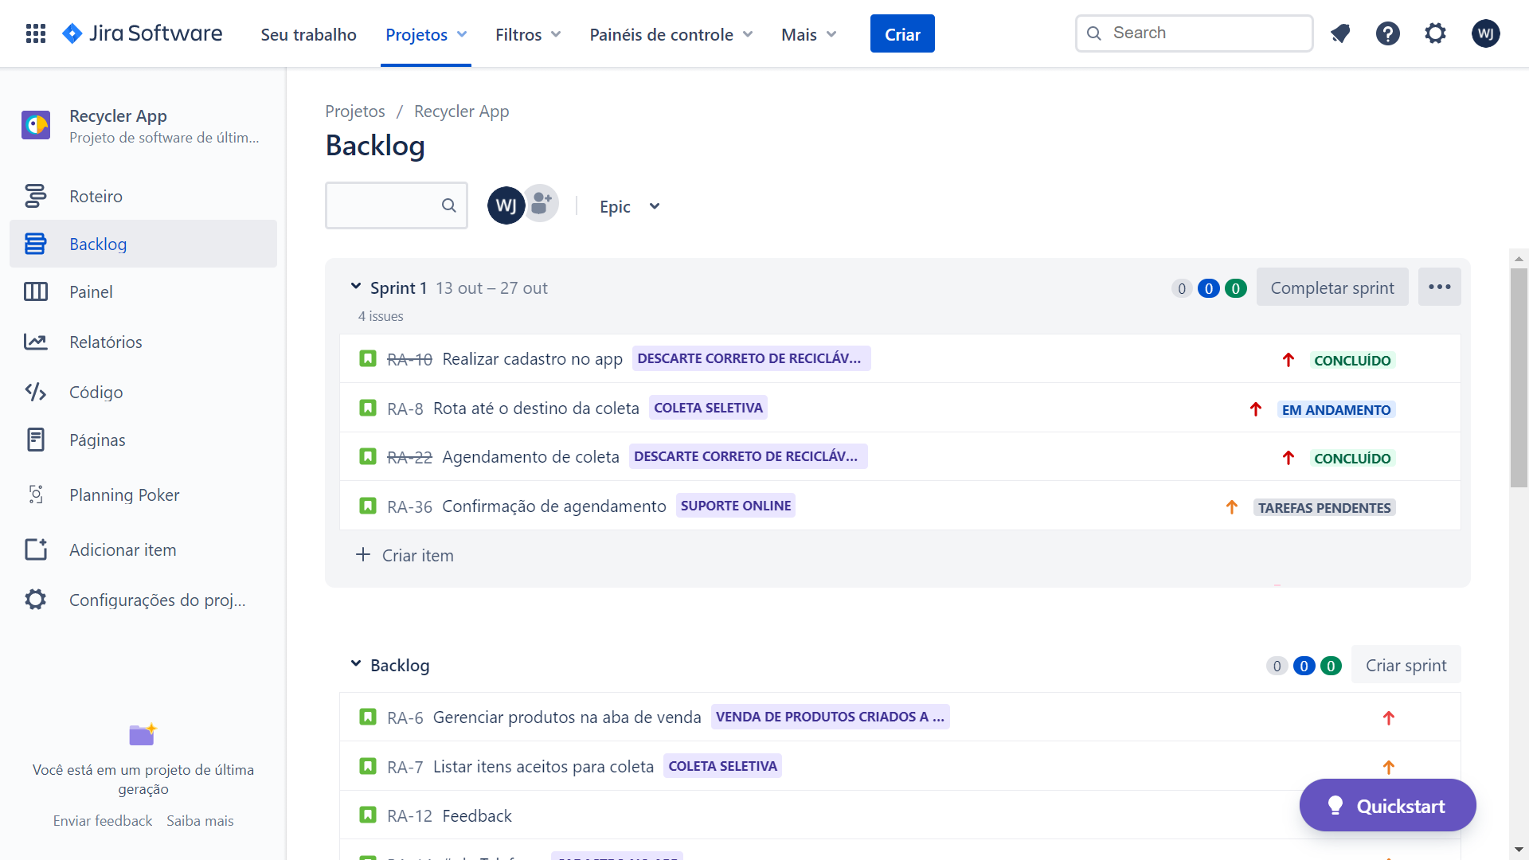

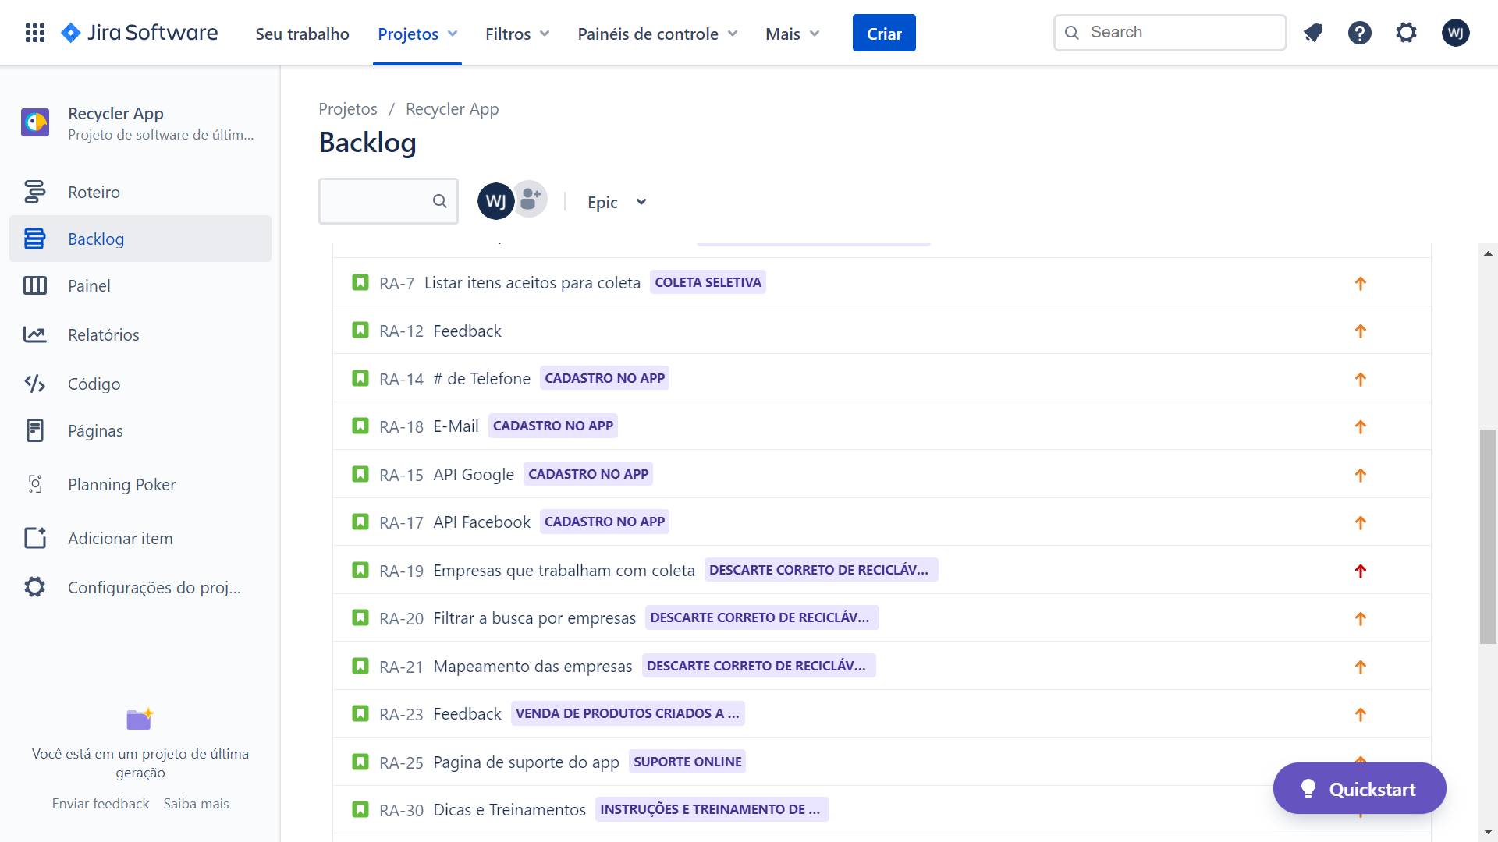

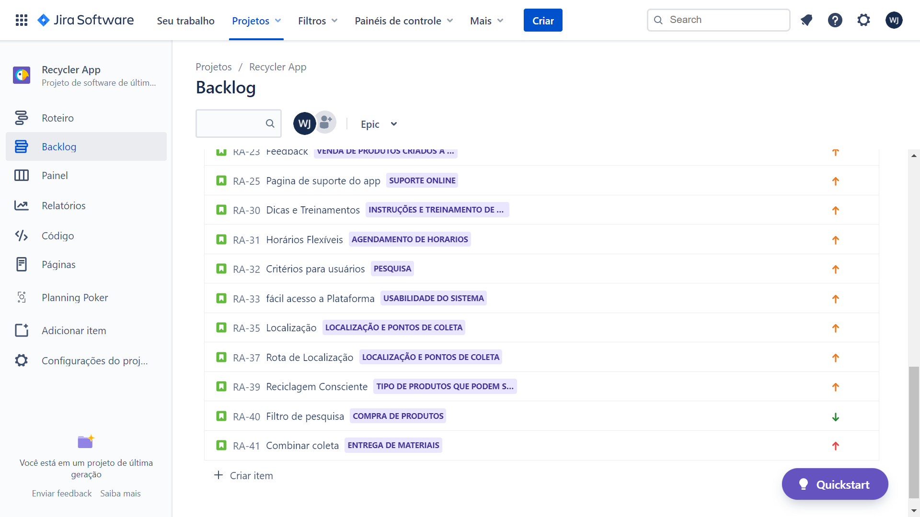

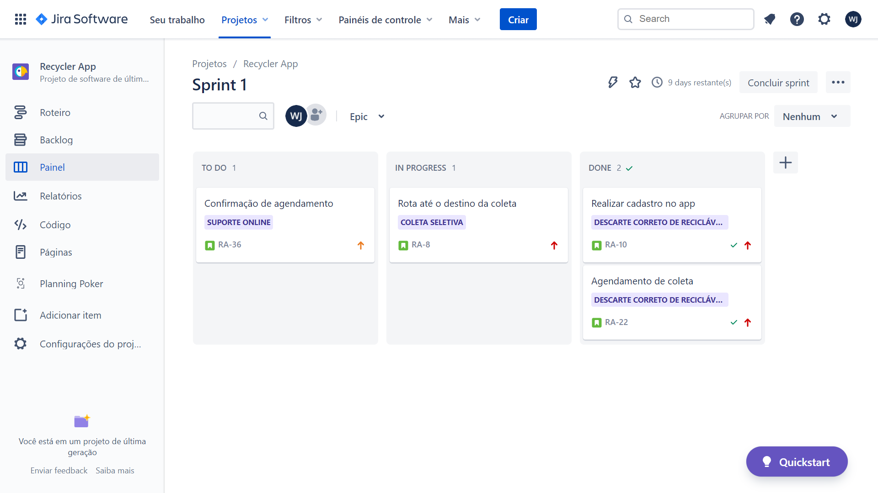

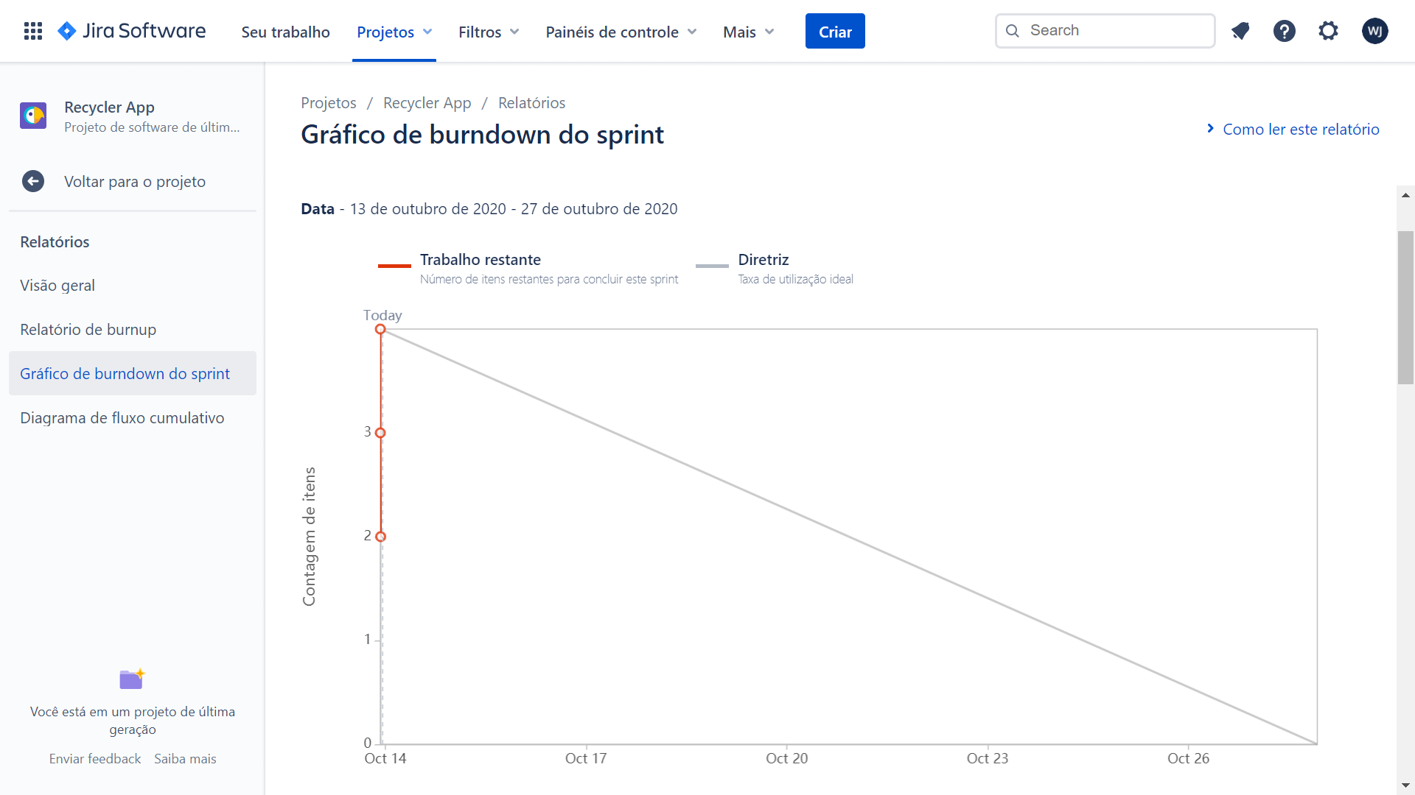

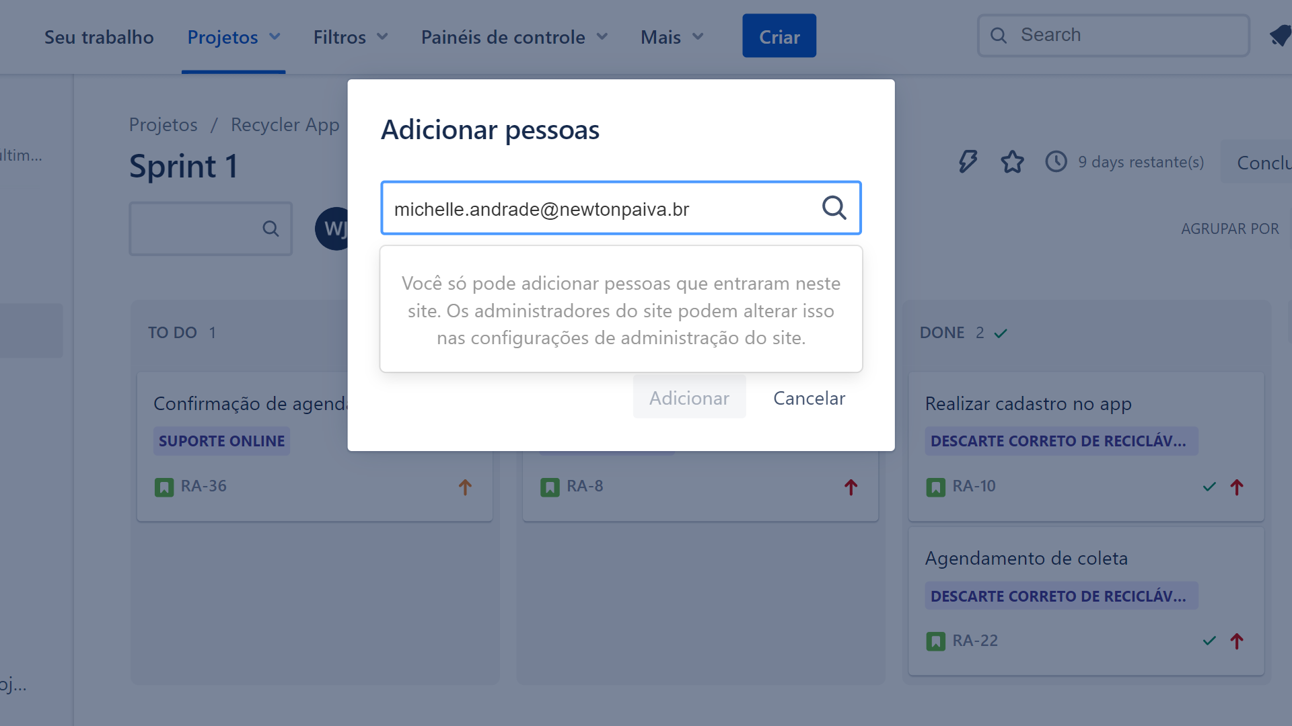

**Link do Projeto Jira: https://morinato.atlassian.net/jira/software/projects/RA/boards/2/roadmap?shared=&atlOrigin=eyJpIjoiMGMxNWQ3MjEyNmE4NDMyNjlkNGFlZTFhMzA0MWNmYmEiLCJwIjoiaiJ9**